**API Integration Report- Rakhshanda’s Closet**

1. Initialized Sanity

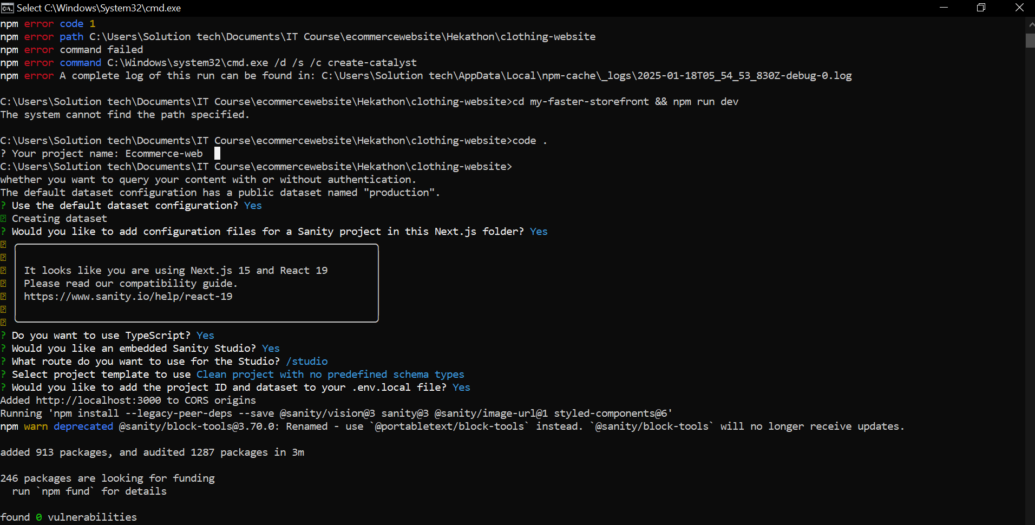

1. Sanity model interface

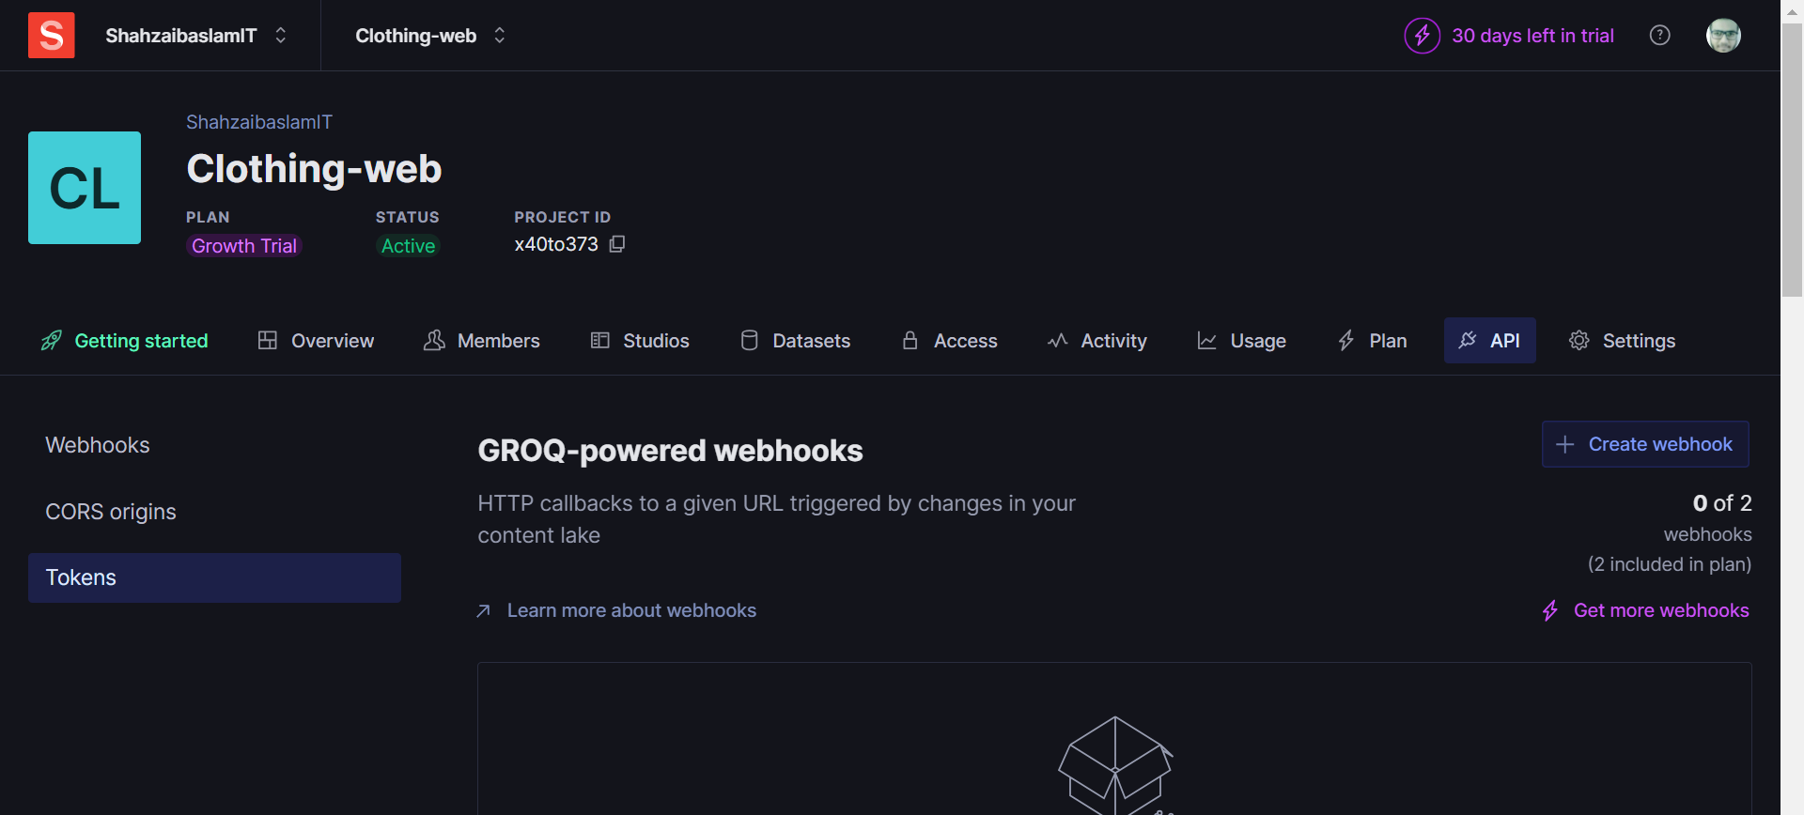

1. CORS Origins registration

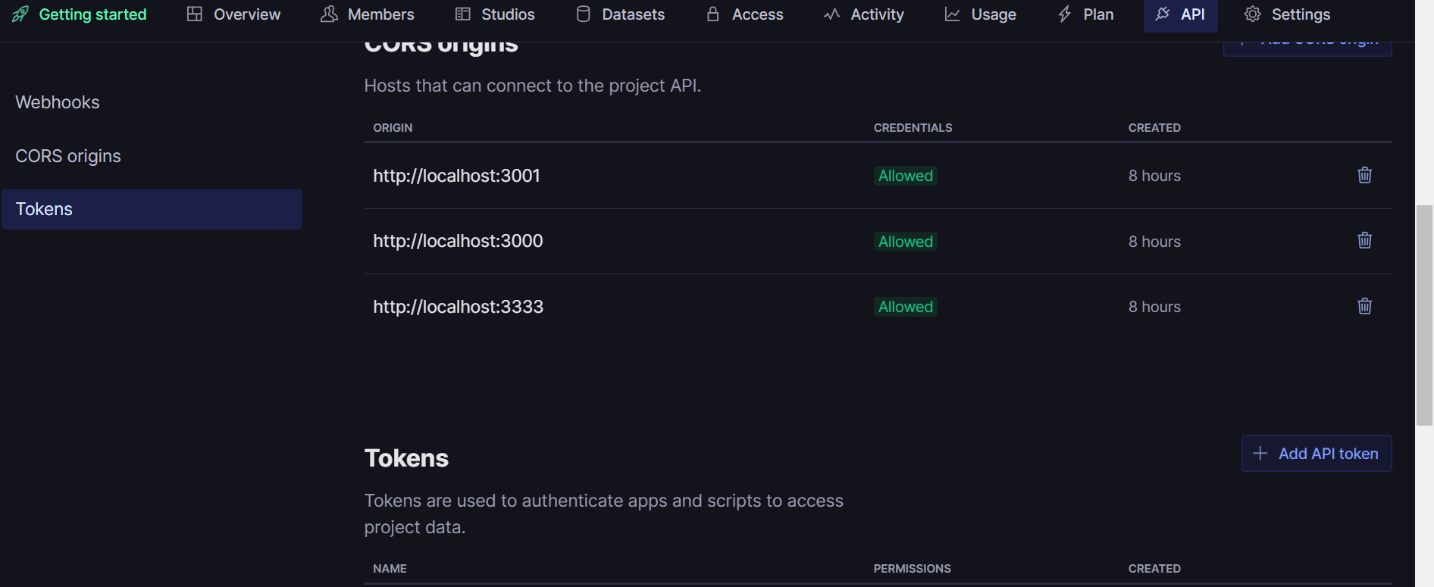

1. API Token for API data

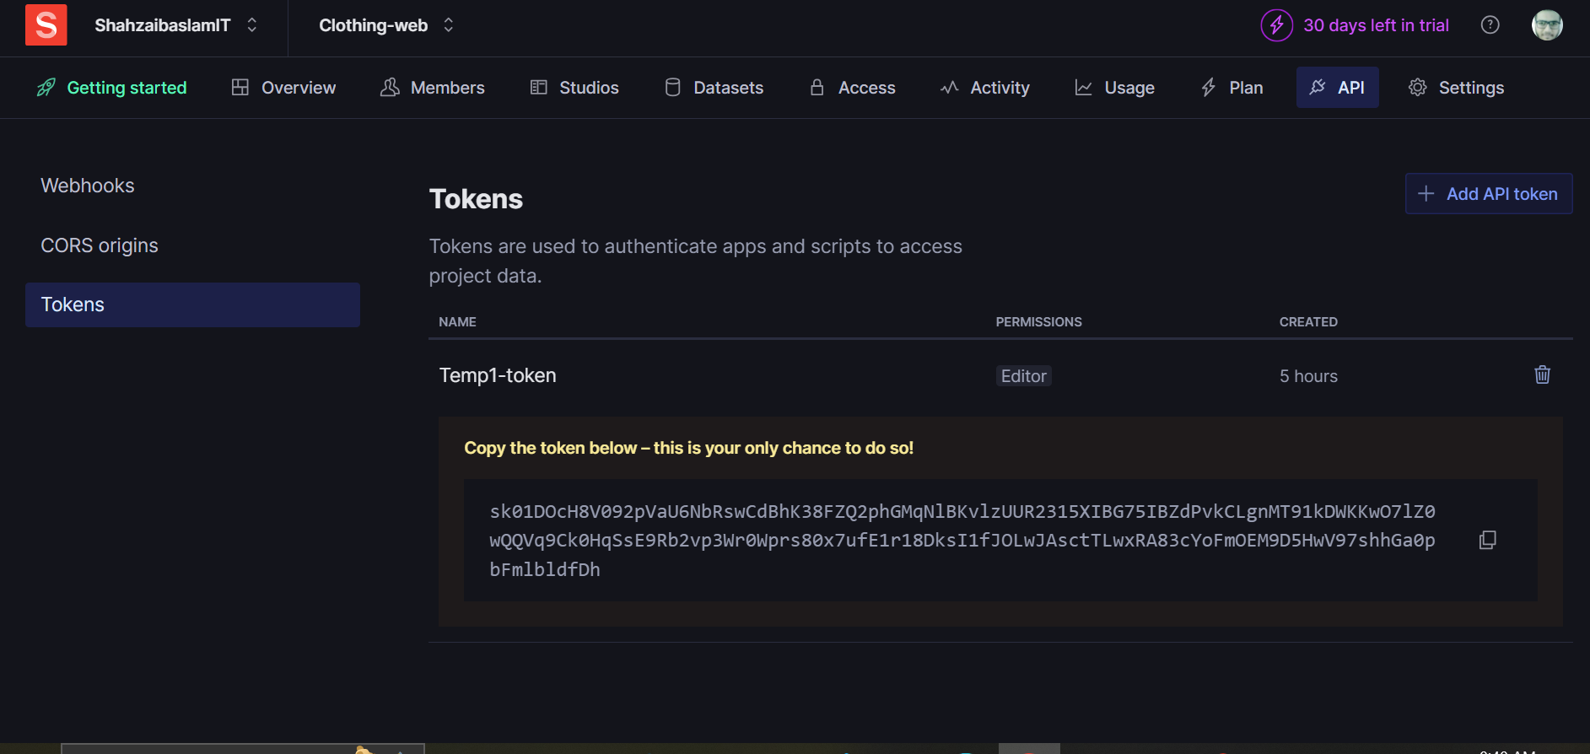

1. Data Schemas of API

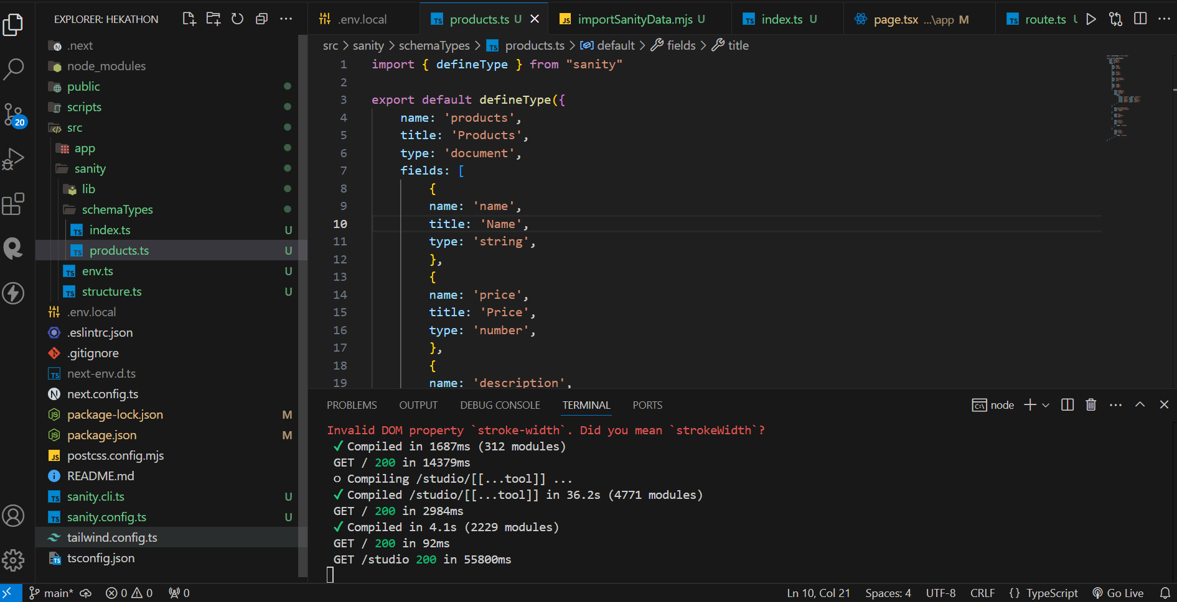

1. Data presentation on Sanity

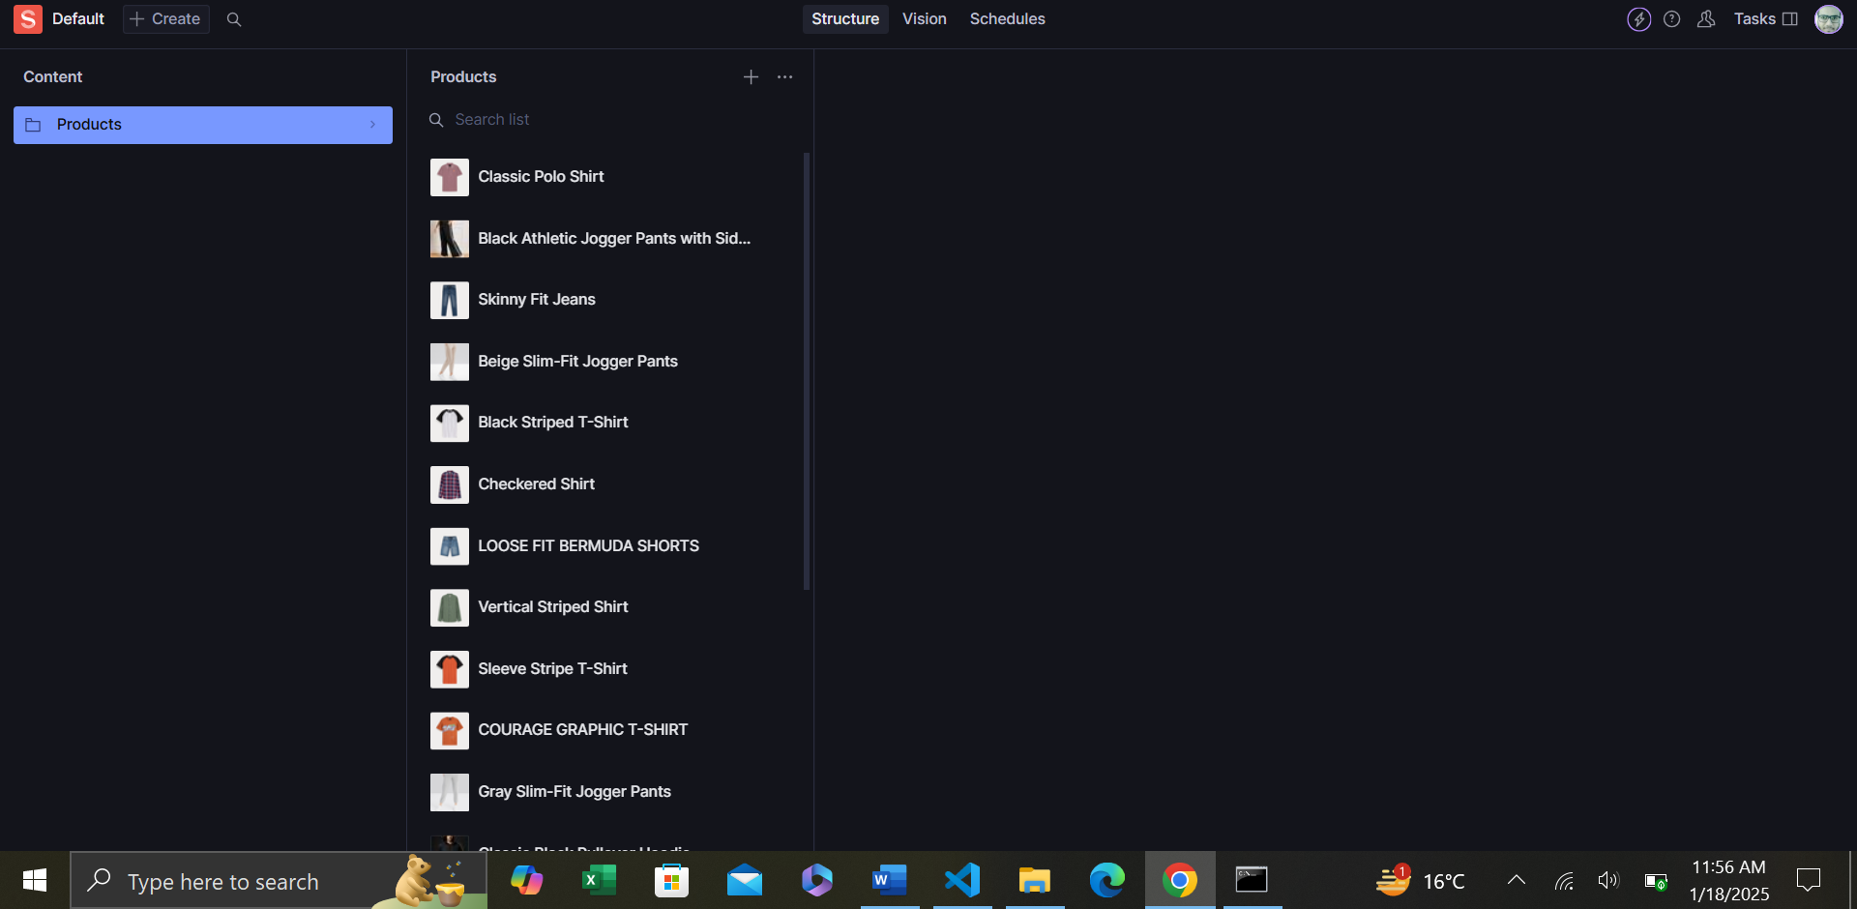

1. GROQ Query for presentation in Sanity

